How to change tomcat port number & GUI User

2019-01-29 0:03:00 Z

**How to send E-Mails from static HTML Website**

In this Example We are going to use Google Spreadsheet

**Login to Google Docs, Go to Spreadsheets**

<https://docs.google.com/spreadsheets/u/0/>

**Make a Copy of this Spreadsheet**

<https://docs.google.com/spreadsheets/d/1Bn4m6iA_Xch1zzhNvo_6CoQWqOAgwwkOWJKC-phHx2Q/copy>

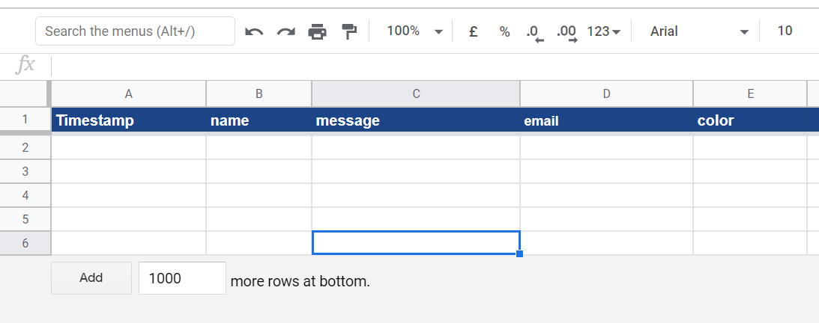

Open the **Script editor…** by clicking “**Tools**” > “**Script editor…**”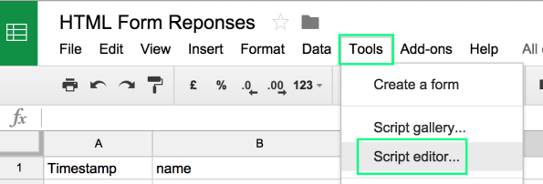

**Place below Code / Change Email-Id of existing code**

var TO_ADDRESS = "**contact.nelsonic@gmail.com**"; // where to send form data

function doPost(e) {

try {

Logger.log(e); // the Google Script version of console.log see: Class Logger

MailApp.sendEmail(TO_ADDRESS, "Contact Form Submitted",

JSON.stringify(e.parameters));

// return json success results

return ContentService

.createTextOutput(

JSON.stringify({"result":"success",

"data": JSON.stringify(e.parameters) }))

.setMimeType(ContentService.MimeType.JSON);

} catch(error) { // if error return this

Logger.log(error);

return ContentService

.createTextOutput(JSON.stringify({"result":"error", "error": e}))

.setMimeType(ContentService.MimeType.JSON);

}

}

[Code Github](https://raw.githubusercontent.com/dwyl/learn-to-send-email-via-google-script-html-no-server/1d1c6727f69dec64a6b7f6bd6ff0dd72d0374210/google-script-just-email.js)

Change Email Id & Save

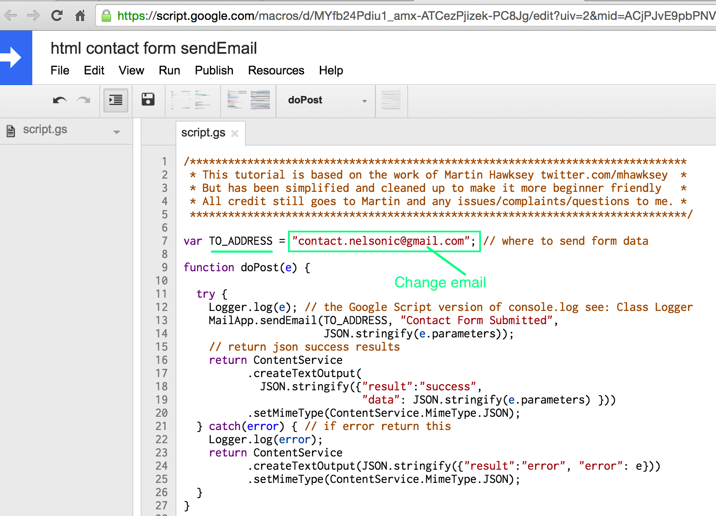

Save & Create Version of script.gs, by **File > Manage Versions > Save Version**

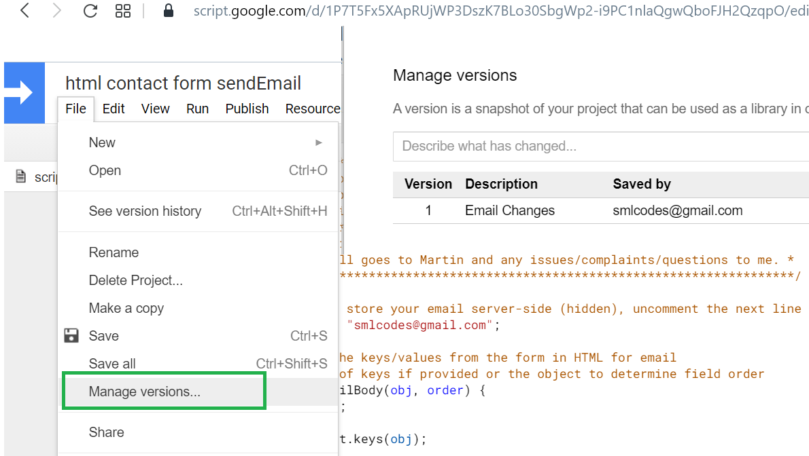

**Publish the *Updated* Script.gs as a Web App**

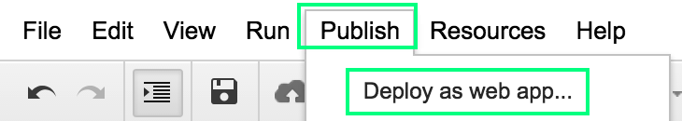

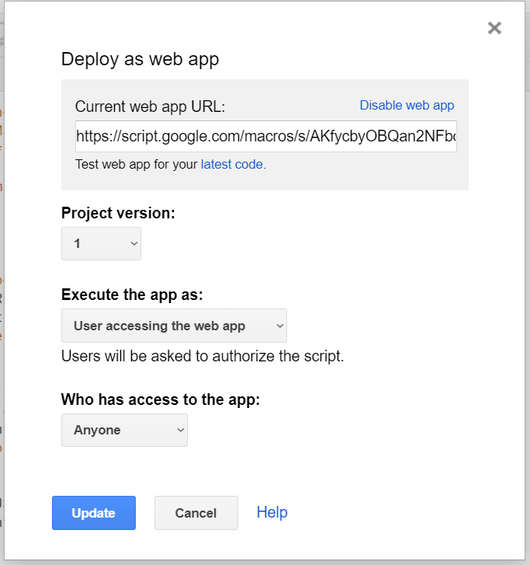

Copy URL

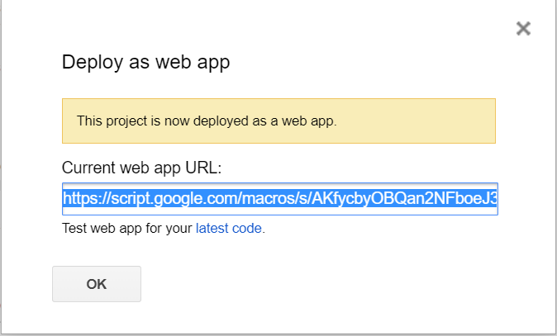

**Create your *basic* HTML Form**

Download HTML File : [Index.html](https://raw.githubusercontent.com/dwyl/learn-to-send-email-via-google-script-html-no-server/master/index.html)

<!doctype html>

<html lang="en">

<head>

<meta charset="utf-8">

<meta name="viewport" content="width=device-width, initial-scale=1.0">

<meta name="description" content="contact form example">

<title>Contact Form Example</title>

</head>

<body>

<h2 class="content-head is-center">Contact Us!</h2>

<aside>

<p>

We would <em>love</em> to hear from you! </p>

<p>Please use the <b><em>Contact Form</em></b>

to send us a message.

</p>

</aside>

<!-- START HERE -->

<link rel="stylesheet" href="https://unpkg.com/purecss@1.0.0/build/pure-min.css">

<link rel="stylesheet" href="https://maxcdn.bootstrapcdn.com/font-awesome/4.4.0/css/font-awesome.min.css">

<!-- Style The Contact Form How Ever You Prefer -->

<link rel="stylesheet" href="style.css">

<form class="gform pure-form pure-form-stacked" method="POST" data-email="example@email.net"

action="https://script.google.com/macros/s/AKfycbzs3xvfgG9eO8y2rwzAF-BBq_XXXXXXXXXXXXXXXX/exec">

<!-- change the form action to your script url -->

<div class="form-elements">

<fieldset class="pure-group">

<label for="name">Name: </label>

<input id="name" name="name" placeholder="What your Mom calls you" />

</fieldset>

<fieldset class="pure-group">

<label for="message">Message: </label>

<textarea id="message" name="message" rows="10"

placeholder="Tell us what's on your mind..."></textarea>

</fieldset>

<fieldset class="pure-group">

<label for="email"><em>Your</em> Email Address:</label>

<input id="email" name="email" type="email" value=""

required placeholder="your.name@email.com"/>

</fieldset>

<fieldset class="pure-group">

<label for="color">Favourite Color: </label>

<input id="color" name="color" placeholder="green" />

</fieldset>

<fieldset class="pure-group honeypot-field">

<label for="honeypot">To help avoid spam, utilize a Honeypot technique with a hidden text field; must be empty to submit the form! Otherwise, we assume the user is a spam bot.</label>

<input id="honeypot" type="text" name="honeypot" value="" />

</fieldset>

<button class="button-success pure-button button-xlarge">

<i class="fa fa-paper-plane"></i>&nbsp;Send</button>

</div>

<!-- Customise the Thankyou Message People See when they submit the form: -->

<div class="thankyou_message" style="display:none;">

<h2><em>Thanks</em> for contacting us!

We will get back to you soon!</h2>

</div>

</form>

<!-- Submit the Form to Google Using "AJAX" -->

<script data-cfasync="false" src="form-submission-handler.js"></script>

<!-- END -->

</body>

</html>

### Ref.

<https://github.com/dwyl/learn-to-send-email-via-google-script-html-no-server>